LUDLUM 2350 DATA LOGGER

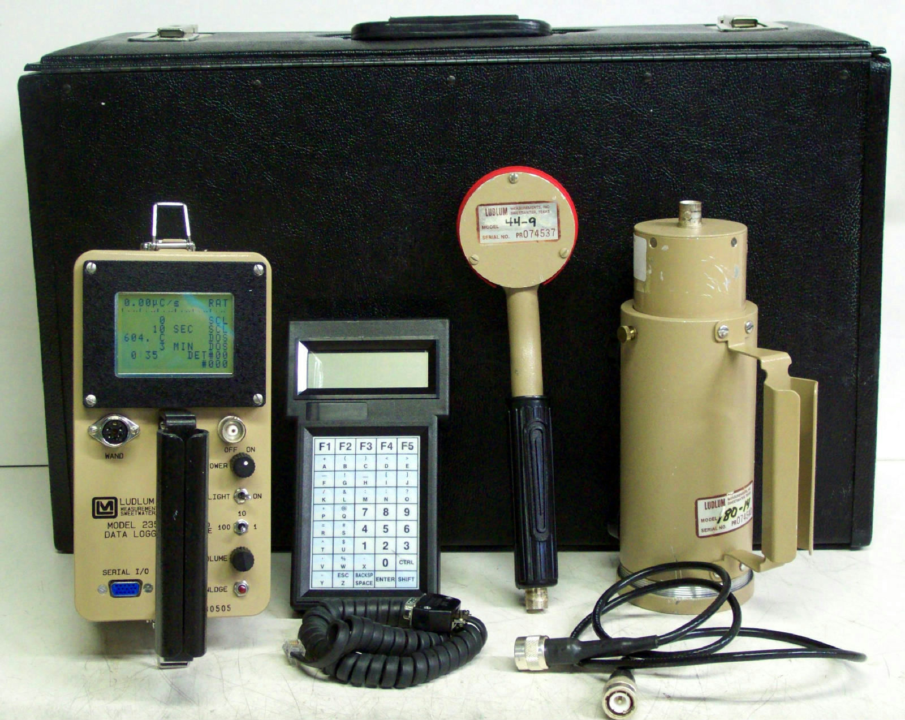

Description

The general purpose Model 2350-1 is Ludlum's most advanced ratemeter/scaler/data logger, and is designed to satisfy a wide range of applications. The large backlit LCD presents bar graphs, digital readings, and logged data on an 8-line by 15-character display. Up to 1000 data points can be stored, along with the location, date/time stamp, detector, count mode, count time, logging mode, and sample number. Location code information can be input via an optional bar code reader.All of the settings are controlled by a small keypad that you plug into the instrument. There is a list of codes, which you use to view the information you need. For example you input one code to see what the high voltage is, another for battery. The instrument can easily be configured for a variety of detector and you can switch between them using another set of codes.

Single-Channel Analyzer Systems

Many SCAs permit the user to select the mode by which the two knobs set the lower and upper levels. In one mode, usually called LL/UL mode, one knob directly sets the lower level and the other sets the upper level. In another mode, called window mode, one knob (often labeled E or energy or T Threshold) sets the midpoint of the range of acceptable pulse heights and the other knob (often labeled ΔE or window) sets the range of voltages around this value. In this mode, the lower level voltage is E − ΔE/2 and the upper level voltage is E + ΔE/2. (In some SCAs, the range of acceptable pulse heights is from E to E + ΔE.) Window mode is convenient for plotting a spectrum.

Plotting a Spectrum Using a Single-Channel Analyzer
To obtain the pulse height spectrum of a sample of radioactive material using an SCA system, the SCA is placed in window mode, the E setting is set to zero, and a small window (ΔE) setting is selected. A series of counts is taken for a fixed length of time per count, with the E setting increased before each count but without changing the window setting. Each count is plotted on graph paper as a function of baseline (E) setting.
Energy Calibration of a Single-Channel Analyzer System
The LUDLUM 2350 permits values from 0 to 1,000 to be selected. By adjusting the threshold and the window the system can be calibrated so that these knob settings directly indicate keV.An Am-241, Cs-137 and Co-60source is used. A narrow window is set, centered about a setting of 662 (for Cs-137). For example, the SCA may be placed into Threshold value of 660 and window 10.

